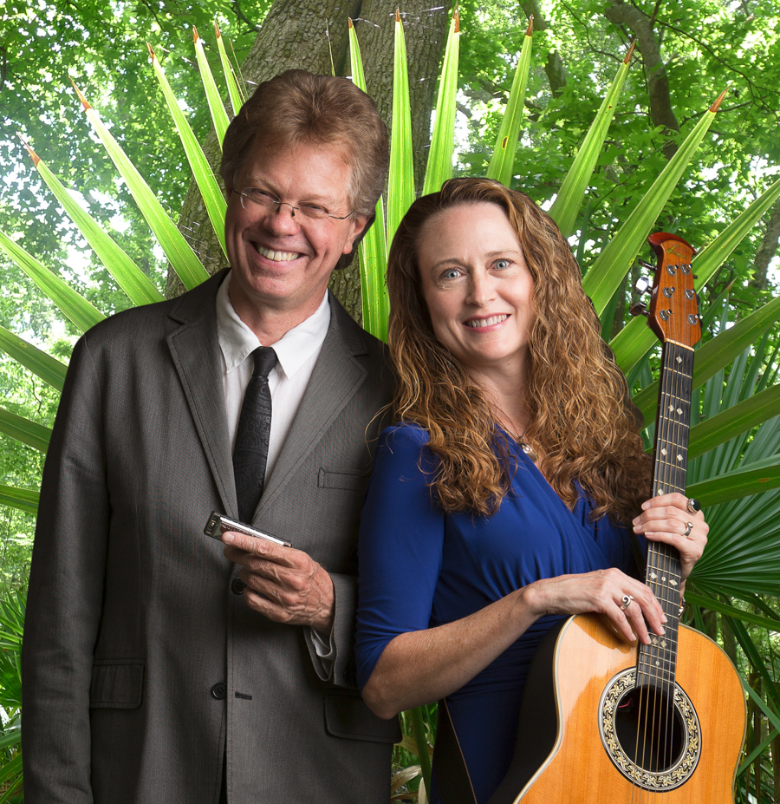
Biography
Johnette Downing developed a love of music at an early age. As a child, her tuba-and-violin playing father and her saxophone-and-piano playing mother took Johnette and her siblings to the French Quarter in New Orleans, where they would stand in the doorways of clubs listening to jazz and ragtime. Her passion for roots music and for sharing music with children, in the way her parents had shared it with her, led Johnette to her career as “the Musical Ambassador to Children” (as media and clients have come to call her). She continues to bring her Louisiana roots music to children in the Middle East, Africa, Asia, Europe, Central America, North America and the Caribbean. The winner of twenty-two international awards for her twenty-five books and eleven recordings for children, Johnette has teamed up with her harmonica-playing husband Scott Billington, who shares her passion for roots music, to form “Johnette and Scott,” a children’s musical duo.
Scott Billington's multifaceted career in the music business began when his mother traded a book of Green Stamps for a harmonica, which she gave the 11-year-old as a Christmas present. By the time he was 16, he was performing in New England coffeehouses and clubs. Pursuing his love of blues and roots music, Scott went to work for Rounder Records in the mid-1970s. He has since produced over 100 albums of roots-oriented music for Rounder and other labels, which have won three Grammy® awards and 11 Grammy® nominations. Other awards include the Sweet Soul Music Award (Italy), the Keepin' the Blues Alive Award (Memphis), and the Offbeat (New Orleans) Lifetime Achievement Award. In recognition of his work in Louisiana, Scott was appointed a Louisiana Colonel by Governor Edwin W. Edwards. His performances as a duet with Johnette Downing again bring his harmonica skills to the fore, in their program of roots music for children.
Program
Swamp Romp – Louisiana Roots Music for Families
It’s a boogie on the bayou when multi-award winning singer and children’s book author Johnette Downing and Grammy® winner Scott Billington come to town with their joyful musical and cultural celebration of Louisiana roots music. Children sing along with Jazz, Cajun, Creole, Blues and Zydeco tunes in an interactive toe-tapping, two-stepping good time. Laissez les bon temps rouler!
Quotes
“Call it a match made in roots music Heaven.” – Herman Fusillier, Offbeat Magazine, New Orleans
“Such classic swamp roots.” – Allen Foster, Songwriters Monthly
“A boogie on the bayou.” – Firehouse Center for the Arts, Newburyport, MA
“Refreshing.” – Rev Down, DittyTV, Memphis, TN
“I love your show. I was a kid again.” – Irma Thomas, the Soul Queen of New Orleans

Performance Highlights
Grammy Museum, Los Angeles, CA
Grammy Museum, Cleveland, MS
Porretta Soul Festival, Porretta, Italy
Segerstrom Center for the Arts Family Festival, Costa Mesa, CA
IGA Conference, Guatemala City, Guatemala
Firehouse Center for the Arts, Newburyport, MA
Nantucket Atheneum, Nantucket, MA
New Orleans Jazz & Heritage Festival, New Orleans, LA
New Orleans Jazz Historical National Park, New Orleans, LA
Acadiana Center for the Arts, Lafayette, LA
High Point Public Library, High Point, NC
Hudson Children’s Book Festival, Hudson, NY
Boo at the Zoo, Audubon Zoo, New Orleans, LA
Louisiana Book Festival, New Orleans, LA
St. Nicholas Fair, New Orleans, LA
French Quarter Festival, New Orleans, LA
Harvest Festival, New Orleans, LA

Media Highlights
DittyTV, Memphis, TN
Steppin’ Out, WYES TV, New Orleans, LA
Morning Show, WWL TV, New Orleans, LA
Apres midi, KRVS Public Radio, Lafayette, LA
Hilltown Family Variety Show, Northampton, MA
Around Town TV Show, Baton Rouge, LA
KATC-TV 3, Lafayette, LA
KLFY-TV 10, Lafayette, LA

